A picture containing clipart

Description generated with very high confidence

Azure 103 Module 4

Hands On - 6

Azure Certification Training

[**support@intellipaat.com**](mailto:support@intellipaat.com)

**+91-7022374614**

**US: 1-800-216-8930(Toll Free)**

**Azure 103 Module 4 , Hands On – 6**

**Assign Static IP to VM.**

**Step 1:** Open route table click your route table.

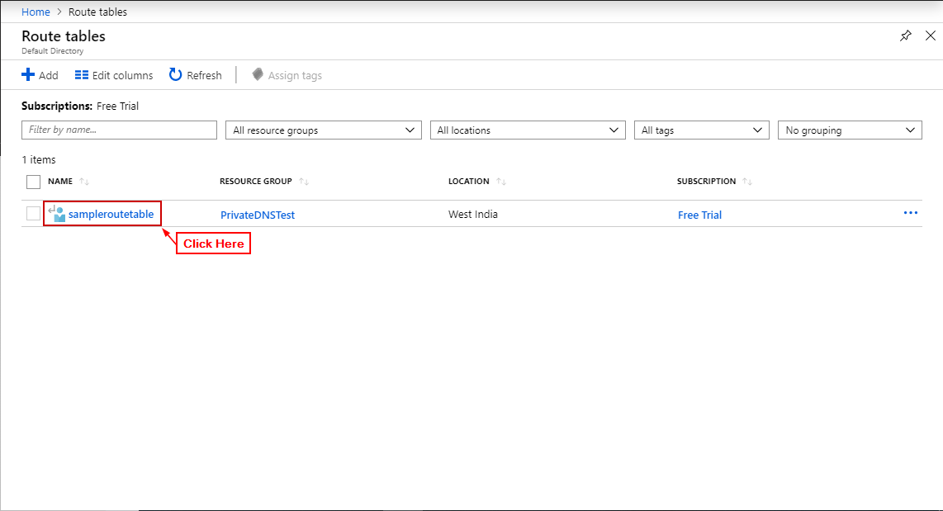

**Step 2:** Click on ’Routes’.

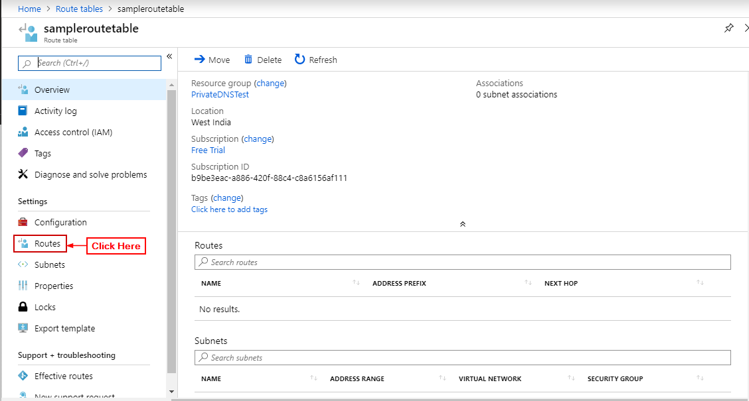

**Step 3:** Enter on ‘+ Add’.

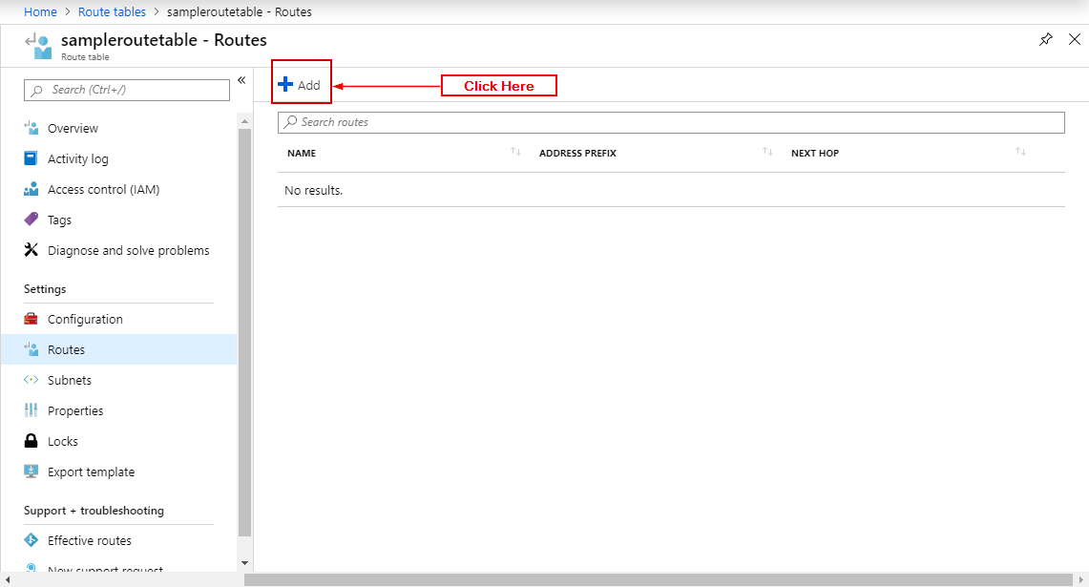

**Step 3:** Enter details and click ‘OK’.

